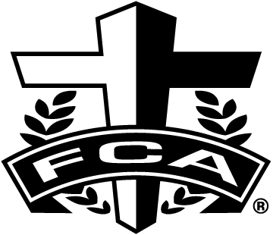

Tuesday October 2, 2012 @5:00 PM
At The Oldham County Youth Soccer Complex
(by Oldham Co. Middle School)
The Fellowship of Christians Athletes and Taylor Orthodontics would like to invite you to the 3rd annual Cross-Country Champions Challenge. It will be held on Tuesday, October 2, 2012, at The OCYSA Complex/Fields by Oldham County Middle School. Races will start at 5:00 PM.
Registration and Information Pick up
Late registration and information pick up will begin at 4:00 PM. There will be NO Team Awards only individuals. Cost to the athlete will be $5.00 per individual. OR Coaches may enter unlimited number of boys for only $25. Unlimited number of girls will be only $25 per team.
Awards and Race Divisions
Top 5 individuals in each division will receive a medal and T-shirt, 6th place through 25th place will receive a medal. No Team Awards will be awarded. Times can be found on the FCA website fcalou.org.
Time Race/Grade Distance
5:00 PM Girls (1st and 2nd grade) 1 mile
5:20 PM Boys (1st and 2nd grade) 1 mile
5:40 PM Girls (3rd and 4th grade) 1 mile
6:00 PM Boys (3rd and 4th grade) 1 mile
6:20 PM Girls (5th and 6th grade) 2miles
6:45 PM Boys (5th and 6th grade) 2 miles
7:10 PM Girls (7th and 8th grade) 2 miles
7:35 PM Boys (7th and 8th grade) 2 miles
Any questions contact Steve Wigginton at 797-9532 with FCA or Bob Bryant at 797-8069. Teams must use Team Manager and the event file to enter their athletes. Individuals can use the attached form, but need to scan it and email it to: SARRETTL@aol.com
“I am able to do all things through Him who strengthens me.” Philippians 4:13
Linda Sarrett Steve Wigginton / FCA
(502)396-4740 400 Blankenbaker Pkwy., Ste. 301
Louisville, KY 40243
(502)245-1514, ofc.; (502)797-9532, cell
FCA/ Taylor Orthodontics Champions Challenge
Entry Form-for individuals only. Teams must use Team Manager and the event file.
($5.00 per individual up to 4 athletes, 5 or more makes a team for $25.00 per boy or girl team)
1st and 2nd grade Division: 5th and 6th grade Division:
Girl / Boy Name Girl / Boy Name
________ __________________________ ________ ________________________
________ __________________________ ________ ________________________
________ __________________________ ________ ________________________
________ __________________________ ________ ________________________

3rd and 4th grade Division 7th and 8th grade Division
Girl/ Boy Name Girl/ Boy Name
________ __________________________ ________ _________________________
________ __________________________ ________ _________________________
________ __________________________ ________ ________________________
________ __________________________ ________ _________________________

Coach’s or Parent’s Name: ________________________________
Mailing Address: ________________________________________
________________________________________
Email address: __________________________________________

Total Number of Athletes: ______ Total Entry: $______ (make checks payable to FCA)

