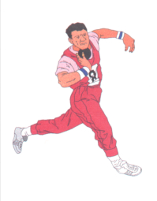
Linda Sarrett – Meet Director
Henry County High School
1120 Eminence Rd
New Castle, KY 40050
(502) 845-8670 (school)
(502) 243-0923 (home)
School fax (502) 845-8671

Dear Coaches,

Henry County High School will be holding its 12th annual Middle School Invitational on April 30th (Oaks Day). The cost for entering this event will be $60.00 for each school. The cost covers both girls and boys teams, with a $25.00 fee for any additional teams you would like to enter. As in the past, Hy-tek and Finish-Lynx will be used. The awards to be given are: A championship trophy to the winning team (both boys and girls), Medals for 1st place and ribbons go to places 2nd- 6th. The Field events will start roughly around 5:00pm, with running events starting at 5:30pm. The events will be as followed

5:00pm
Long Jump – Boys, then Girls – 3 jumps
High Jump – Girls, then Boys
Shot - Girls, then Boys – 3 throws
Discus - Boys, then Girls – 3 throws

5:30pm
4x100m relay
800m relay
100m hurdles
100m Dash
400m Dash
300m hurdles
200m Dash
1600m run
4x400m relay

From all of us at Henry County High, we hope to see you all on Oaks Day!

Sincerely,
Linda G. Sarrett

