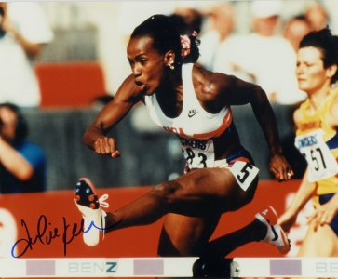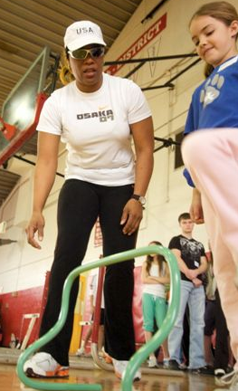

Jackie Joyner-Kersee
&
Sharrieffa Barksdale

Track and Field Summer Camp
Sprints, Speed, Throws, Jumps and Hurdles
Jackie Joyner-Kersee
&
Sharrieffa Barksdale

Track and Field Summer Camp
Sprints, Speed, Throws, Jumps and Hurdles
Registration: 12:30pm
1:00 p.m. – 4:00 p.m. (Ages 7-18)
When: June 7th – June 9th 2010
Time: 1:00pm to 4:00pm
Cost: $300.00
Place: Mercer Co High School
371 E. Lexington St
Harrodsburg, KY 40330
859-519-7131
Blairs3833@yahoo.com
Scholarships are still available

Sharrieffa Barksdale
1984 Olympian 400m Hurdles
Former American Record Holder
2008 Olympian Pool Manager
859.519.7131

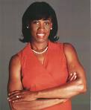

Jackie Joyner-Kersee
&
Sharrieffa Barksdale

Track and Field Summer Camp
Sprints, Speed, Throws, Jumps and Hurdles

When: June 7th – June 9th 2010
Time: 9:00am to 4:00pm
Place: Henry Clay High School
2100 Fontaine Road
Lexington, KY 40502
859-519-7131
Blairs3833@yahoo.com

Join 4x Olympian Jackie Joyner-Kersee
1984: Olympic Silver in heptathlon.
1988: Olympic Gold in heptathlon and gold in long jump.
1992: Olympic Gold in heptathlon and bronze in long jump.
1996: Olympic Bronze in long jump.
2x Olympian Sharrieffa Barksdale
1983: Former American Record Holder 400 meter Hurdles
1984: Olympic 400 meter Hurdles
2008: Olympic Asst. Manager
Looking to increase your child’s speed in track, basketball, baseball, soccer, tennis and football; you have come to the right place. This will be one of the best sprint and fundamentals camps your child would have attended.

Please don’t wait to register, the camp will have a limited enrollment and the registration deadline is one week prior to camp date...
Please make checks or money orders to: Heptathlon LLC
Henry Clay High School
2100 Fontaine Road
Lexington, KY 40502
Attn: Coach Barksdale/Coach Gay

Open to boys and girls 7-18 year of age

Registration: 8:00am- 8:45am
Session 1: 9:00 a.m. – 12:00 a m (Ages 7-11)
Session 2: 1:00 p.m. – 4:00 p.m. (Ages 12-18)
Cost: $300

Each Camper Receives:
• Camp T-shirt
• Autographed Camp Photo
• A great Experience Guaranteed!

Coaches are invited to attend this camp: Cost $200.00
Each day campers experience:

Sprints:
Speed is a vital part of success in every sport. Athletes from many sports track, football, baseball, softball, soccer, and tennis have attended my camps. During the Three -day camp, campers will be instructed in; sprinting drills, block starts, 40 yard dash, techniques, form running, relay exchanges and acceleration and speed maintenance.
Throws:
The throws will be covered in detail. Not only will campers learn how to throw but also they will learn how to train for the throws. The discus and the shot put will be covered in great depth.
Jumps:
Campers will have the opportunity to work with Olympians in the high jump, and long jump. The high jump approach will be broken down into simple learnable parts. The long jump will be covered start to landing. Each part of the jump will be broken down by Jackie Joyner Kersee, campers will be able to see and correct faults in their technique.
Hurdles
Campers will learn proper hurdling techniques for both the long and the short hurdles. Campers will learn how to alternate lead legs to prevent lost of momentum during the hurdle race. Hurdle drills and excellent coaching will better prepare all campers for the next track and field season. These drills will be broken down by Jackie Joyner Kersee and Sharrieffa Barksdale.

CAMP APPLICATION
Name________________________________________Address______________________________________
City________________________ State_________ Zip_____________ Age at camp ________
Parents’ Names________________________________Home Phone #_________________________________
Emergency #__________________________________School_______________________________________
Email Address ____________________________

I wish to enroll in the following session(s): $300 per camper
􀀀 June 7th-June 9th (Day Camp) Age 7-11 􀀀 June 7th-June 9th (Day Camp) Age 12-18
$250 per camper 5 or more (Group Rate)

Make check or money order payable to: Heptathlon LLC
Return camp fee and application to
Henry Clay High School
2100 Fontaine Road
Lexington, KY 40502
Attn: Coach Barksdale/Coach Gay

I give the camp permission to use any camp-related photos of my child for camp publicity.
Undersigned being a parent or legal guardian of the child requesting camp admittance, does hereby affirm that the applicant is physically able to perform activities conducted at Jackie Joyner-Kersee and Sharrieffa Barksdale Track and Field Sprint and Speed Summer Camp. I hereby give my permission for the medical staff to perform any necessary medical procedures on this camper in the event of sickness or injury. I understand that, as a condition of admittance as a camper, the undersigned, on behalf of all parents and guardians, and on behalf of the applicant, hereby releases Jackie Joyner Kersee and Sharrieffa Barksdale and other volunteers workers of the camp of any and all liability from injury or illness, mental or physical, suffered by the camper during or related to camp, unless caused by the willful act or gross negligence of the person or entity against whom the claim is made.
The camper is covered by:
Insurance Company ___________________________ Policy No. ___________________________________
Applicant’s Signature __________________________ Parent or Guardian Signature ____________________
WAIVER STATEMENTS
I/We, the undersigned, hereby certify that I (we) am (are) the parent or legal guardian of the camper ___________________________.I hereby give permission for the training staff of the Jackie Joyner-Kersee and Sharrieffa Barksdale 3 day Sprint and Speed Summer Camp to seek during the period of the Camp appropriate medical attention for the camper and for the medical attention in the event of accident, injury, or illness. I the parent of _________________________ will be responsible for any and all costs of medical attention and treatment, except for that covered by the Clinic’s excess medical coverage policy.
I/We, the undersigned, hereby acknowledge and understand that the JJK and SB Track Camp is a privately run sports clinic, and is not operated by or through Henry Clay High School. The Camp is neither sponsored, controlled, nor supervised by Henry Clay High School.
I/We, the undersigned, for ourselves, our heirs, executors and administrators, waive, release and forever discharge Henry Clay High School, Jackie Joyner-Kersee, Sharrieffa Barksdale and its staff, assigns from any and all liability, claims, demands, actions, and causes of actions whatsoever arising out of or related to any loss, personal injury of property damage that may be sustained or occur during participation in Camp activities or while at Camp.
________________ _________________ ________________ _________________
Athlete Signature Date Parent Signature Date

