ECHS Run at Mammoth Cave National Park

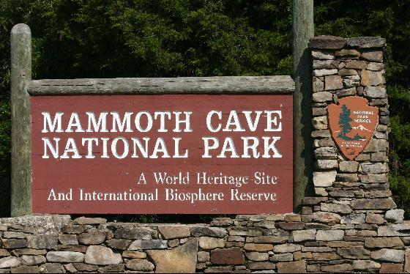
5K Run & 5K Walk

RACE START: Mammoth Cave National Park/Mammoth Cave Hotel
PLACE: Mammoth Cave, KY
DATE: August 7th, 2010
TIME: ALL REGISTRATION MUST BE DONE BY PRE-REGISTRATION –– 5K / 8:00 AM
FEE: 5K -$15.00 high school cross country runners $10.00

5K MENS OVERALL TOP 3 5K WOMENS OVERALL TOP 3
14 UNDER – 3 30 To 34 –3 50 To 54 –3 14 UNDER–3 35 To 39 –3 55 To 59 – 3 60 Over - 3
15 To 19 –3 35 To 39 –3 55 To 59 –3 15 To 19 –3 40 To 44- 3
20 To 24 –3 40 To 44 –3 60 OVER –3 20 To 24 –3 45 To 49 – 3
25 To 29 –3 45 To 49-3 25 To 29 –3 45 To 49 –3 30 To 34 -3 50 To 54-3
WALKERS WILL BE AWARED TOP 5 - MALE AND FEMALE

MAIL ENTRY FEES TO AND MAKE CHECKS PAYABLE TO:
ECHS CROSS COUNTRY & TRACK
440 Brier Creek Meadows
Mammoth Cave, KY 42259
270-286-6366

Name:____________________________________________________ Address:________________________________________
City/State/Zip:_______________________________________________________ Phone: ( _____ )______________________
M _________ F _________ Age Race Day: ___________ Birth Date: _______________________ T-Shirt Size: ___________
Emergency Contact: ___________________________________________________ Phone: ( _____) _____________________
Race Wavier (please read carefully)
In consideration of the acceptance of this entry, I hereby, for myself, my heirs, executors, administration and assigns, and anyone entitled to act on my behalf release and discharge plus sponsors, their representatives and successors, managers, directors, officials, agents, employees, Mammoth Cave National Park and volunteers of road race named in the above entry form from any and all claims of injury or liabilities of any kind, illness or damages suffered by me, as a result of my participation in or traveling to or from this event. I know that running or walking a road race is a potentially hazardous activity. I should not enter and run or walk unless I am medically able and properly trained, I agree to abide by any decision of a race official relative to my ability to safely complete the run or walk. I assume all risks associated with running or walking in this event, including, but not limited to, falls, contact with other participants, the effects of the weather (including high heat or humidity), traffic and the conditions of the road, all such risks being know and appreciated by me. I realize that this is a strenuous event, which requires proper physical conditioning. I hereby certify that I am in such physical condition and good health. I also give my permission for the free use of my name and picture in any written account, broadcast, or telecast of this event for any legitimate purpose. This form was designed for running and walking events only.

Signature (Parent or Guardian, if under 18) Date

