3rd Annual

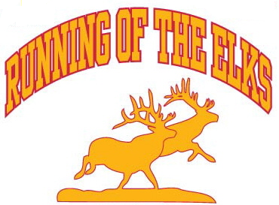
Cross Country Meet

September 25th, 2010

Location: State Archives on Coffee Tree Road in Frankfort, KY

Dear Coaches:

Elkhorn Middle School (Coach Jim Beason) and Franklin County High School (Coach Kelly Lewis) in Frankfort Kentucky will be hosting the “Graviss McDonald’s Restaurants Running of the Elks” Cross Country Meet on September 25, 2010. This meet will offer Elementary, Middle School, and High School races at the State Archive in Frankfort Kentucky where the Vietnam Memorial is located. We are hoping to see as many local schools and others at this event as possible.

Schedule & Entry Fees:

Race | Time | Distance | Team Fee | Individual Fee | # of runners | Individual Awards
Coaches Meeting | 8:45 AM
Girls High School | 9:00 AM | 5000 meters | $40.00 | $8.00 ($40 max) | 10 | 25
Boys High School | 9:45 AM | 5000 meters | $40.00 | $8.00 ($40 max) | 10 | 25
High School Awards | 10:30 AM
Girls Middle School (6-8th grade) | 10:45 AM | 3000 meters | $35.00 | $7.00 ($35 max) | No limit | 25
Boys Middle School (6-8th grade) | 11:15 AM | 3000 meters | $35.00 | $7.00 ($35 max) | No limit | 25
Middle School Awards | 11:45 AM
Girls Elementary (5th grade & under) | 12:00 PM | 1500 meters | $30.00 | $6.00 ($30 max) | No limit | 25
Boys Elementary (5th grade & under) | 12:30 PM | 1500 meters | $30.00 | $6.00 ($30 max) | No limit | 25
Elementary School Awards | 1:00 PM

THERE IS A LIMIT OF TEN (10) RUNNERS PER TEAM IN HIGH SCHOOL. MULTIPLE TEAM ENTRIES ARE PERMITTED FOR AN ADDITIONAL $8 FEE PER TEAM. NO LIMIT (ONE FEE ANY SIZE TEAM) IN MIDDLE AND ELEMENTARY RACES. NOTE: A HIGH SCHOOL RUNNER IS NOT PERMITTED TO COMPETE IN ANY OTHER DIVISION LEVEL. IF THIS DOES OCCUR, BOTH TEAMS RUNNER RAN FOR WILL BE DISQUALIFIED.

Awards:
Top two (2) teams in each race receive trophies at associated presentation.
Top six (6) runners will be presented plaques at their associated presentation.
The remaining places through twenty-fifth (25) place will receive a ribbon.
(RIBBONS: Will be sent to teams within a weeks time with runners name place and time on backs)
NOTE: Awards are subject to change depending on the number of runners/teams.

Meet Entry Deadline:
Team Entries will be accepted until Monday September 20th, 2010 at midnight (EST). Unattached runners entries will be accepted until Saturday September 25, 2010 at 8:30 AM (EST). All entries after the mail in fee date are subjected to the late fee.

Early Submission Discount:
Team entry fee submissions postmarked by August 31, 2010 will be discounted $5.00 per Entry Level.
(ie Elementary Boys $30.00 and Elementary Girls $30.00 = $60.00 – discount for entry level = $55.00) Only one discount per entry level will be accepted.

Mail entry fees to:
“Graviss McDonald’s Restaurants Running of the Elks”, Attention: Jim Beason, 204 Farmbrook Circle, Frankfort, KY 40601. Please make checks payable to “Elkhorn Middle School Cross Country” and note in the memo area “CC Meet Fee”. Entry fees should be post marked no later than September 15th, 2010 or an additional $30.00 late fee will be added to the associated school’s cost when payment is presented at the meet.

Send Team Entries to:
Email Frank Miklavcic (fmiklavcic@aol.com) your Hytek Team Manager entries. Only Hytek Team Manager entry files will be accepted. Information on using the free version of Hytek Team Manager is at www.ktccca.org.

For individual questions contact:
Coach Jim Beason at coach.beason@fewpb.net via email. Elkhorn Middle School phone number is 502-695-6740. EMAIL IS PREFERRED.

Please note that we are looking to have a concession stand and meet T-shirt available during the meet.

Directions to the State Archives:

From Lexington to Frankfort:
Take I-64 West to the first Frankfort exit. Take US 60 West to the East-West Connector (676). Follow the Connector to Coffee Tree Road (just before you get to the river) Take a left onto Coffee Tree Road. Follow Coffee Tree up and around the hill until you see the Vietnam Memorial.

From Louisville to Frankfort:
Take I-64 East to the first Frankfort exit. Take 127 North to the East-West Connector (676). Follow the Connector until you cross the Kentucky River. Across the bridge take the first right. This is Coffee Tree Road. Follow Coffee Tree up and around the hill until you see the Memorial.

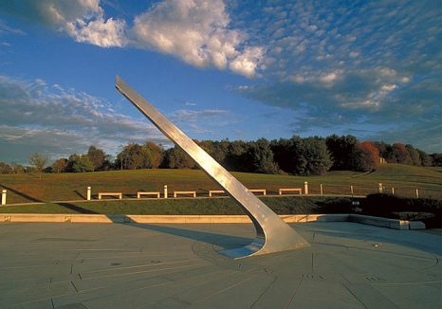

Picture: Vietnam Memorial where the “Running of the Elks” will take place.

