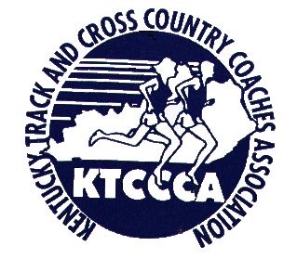

KTCCCA Kentucky Senior Challenge
The KTCCCA will be hosting the Cross Country Coaches National Youth Championships at Masterson Station Park, Saturday, November 20. Our Senior Challenge this year, instead of competing against different areas of the state, will have five teams of eight seniors competing for the Cross Country Coaches National Youth Championships in the 17-18 year old division. The selection committee will select the top 40 seniors with the first team being the top eight seniors, etc. The girls race will be at 10:00 AM. The boys race will be at 10:30 AM. CCCNYC top 25 and team awards will be at 11:45. There will be an awards banquet for Kentucky seniors at 12:30 at the Lions Club Pavilion inside the Fairgrounds. There will be no charge for the seniors. A reminder, we realize that not all of the top seniors will be able to compete so please indicate your interest even if you do not feel like you are currently in the top 40.
Uniforms will be provided for the forty team members (40 boys & 40 girls). Note all seniors are invited to compete in the race at no cost. If a senior is not selected for the team, they or the coach needs to email fmiklavcic@aol.com to get a competitor number for the race. David St. Louis (steeplecoach@gmail.com ) and Tim King (king4@fuse.net) will be coordinating selection with assistance from Jonathan Grooms. Each athlete will be required to fill out a YES Athletics membership form. This will be provided. Note since this is an age group meet, we may have some junior who are 17-18 filling some slots on teams.

