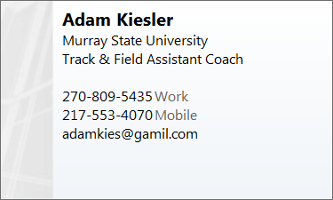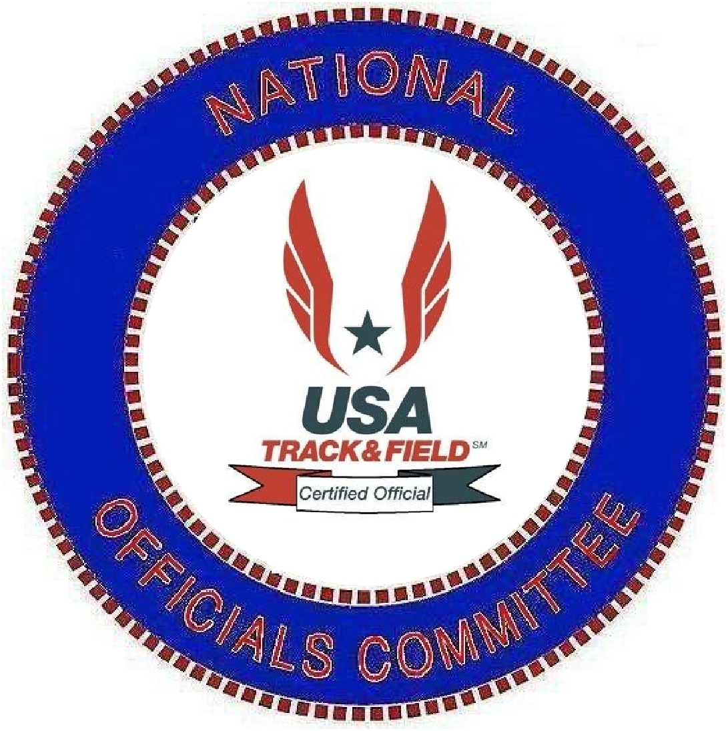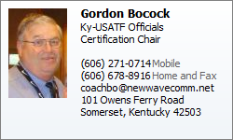
Murray State University USATF Officials Certification Clinic. This is your next opportunity to get certified as a Track and Field Official
The Ky-Association of USATF Track and Field will be hosting a USATF Track and Field Officials Certification Clinic on Tuesday, February 15 on the campus of the Murray State University. Murray Track and Field Assistant Coach Adam Kiesler will be the local Host for the Clinic. Clinic will be held in Stewart Stadium Room 205.
Murray State and the Track and Field staff would like to invite anyone in the area that has been involved in track and field, the opportunity to give back to the sport. This clinic is basic training for anyone that thinks they might be interested in getting back in the sport. Former high school athletes, former collegiate athletes, former or current high school or college coaches that still have a desire to stay involved in the sport, this may be the opportunity you have been looking for.
Parents who enjoy watching young athletes this could be what you need to help you know the rules a little better so you can help local teams putting on track meets.
The Clinic will be a 4 Hour Clinic . . . 5:30 till 9:30 Central Time. The cost of the clinic is $25.00. For more information you can contact Coach Kiesler or Coach Bocock who will be the USATF Official conducting the clinic.
Please e-mail us with if you plan to attend the clinic so we can make sure we have enough handouts as well as letting you know if weather requires us to set the clinic at a later date.

QUALITIES & CONSIDERATIONS FOR A
GOOD TRACK & FIELD OFFICIAL

Responsibility
Create a competitive environment in which each competitor has a fair opportunity to achieve her/his best performances

Approach
1. Athlete Centered. The interests of the athletes must be considered as primary. The competitors are the central reason for having a meet, not the officials or spectators.
2. Proactive. Take proactive steps to avoid having to make a call.
3. Consistent. Treat all competitors and events equally

Key Qualities
1. Maintain impartiality in every situation and every event.
2. See every meet and event as important.
3. Always consult the rulebook to verify non-routine rulings. Don’t be afraid to ask or check.
4. Be understanding of athletes' needs and circumstances– be present, but not highly visible.

01/2008

DID YOU KNOW?

A properly run track meet can require over 70 officials. On a typical spring weekend in the Puget Sound area, four such meets may be scheduled—each staffed predominantly by volunteer officials and dedicated parents.

Several of our senior officials have served at NCAA and US Championships as well as the Olympic Games.

PUTTING ON AN EVENT? CONTACT US!

Pacific Northwest Track & Field Officials Association, although a separate organization from Pacific Northwest Track & Field (PNTF), works closely with PNTF to work meets in Western Washington. We are also available to help other groups with their meets.

For further information on having us at one of your meets, contact President Geof Newing:
gnewing@comcast.net

www.pntf.org 206-433-8868

Pacific
Northwest
Track & Field Association

BECOME A
TRACK & FIELD/
CROSS-COUNTRY
OFFICIAL

• Support your local athletes •
• Enjoy the excitement of track & field and cross-country •
• Have fun and make new friends •
• No experience necessary •
Why Officiate Track & Field Instead Of Baseball, Soccer, Etc?
- You can contribute right away — no certification or schools required
- Flexible scheduling — only need to commit to one meet at a time. Work weekdays and/or weekends
- A variety of events and assignments are available — work the ones you like
- Work as much or as little as you want at each meet — from 2 hrs up to all day
- Work any or all levels from a major NCAA invitational to a youth club meet
- Work with top athletes at each level
- Supportive/appreciative fans & parents

Do I Need A Track & Field Background?
No. While many of our officials are former athletes or coaches, many others are simply fans of track & field/cross-country, or participate out of a desire to volunteer.

What Can I Expect While Starting Out?
Beginners usually rotate duties — as timers and finish line judges for running events, or, for field events, they measure jumps and throws and set crossbars.

After gaining experience, officials serve as race umpires and relay judges, or as field event chiefs — keeping score, calling fouls, coordinating athletes and ruling on infractions.

Additionally, you can help with results and finish line computers or assist the clerk of the course with lane assignments and check-ins.

Flexibility is key — as officials, we take pride in doing whatever it takes to keep the meet running smoothly.
Typical Track & Field Events
100M Dash 4x100M Relay 100M Hurdles 200M Dash 4x400M Relay 400M Hurdles
400M Dash Decathlon Steeplechase
800M Run Long Jump Hammer
1500M Run Triple Jump Shot Put
3000M Run High Jump Javelin
5000M Run Pole Vault Discus

Levels of Competition
High School Masters
NCAA and NAIA Club
USA Track & Field Youth
Special Olympics Junior Olympics

Calendar
Indoor T&F runs mid-January to March. Outdoor HS/College season runs March to June. Club and youth events run throughout the summer. Cross-Country runs September to December. Most meets are on Saturday, except HS dual meets are usually weekday afternoons. Men’s and women’s competitions are scheduled together.

Rewards
While officials as a rule are volunteers, you can usually expect a free lunch and an occasional t-shirt. Larger meets often provide a voucher for a post-event dinner.

Some championship meets do pay for certain positions. Your expenses as a volunteer are tax deductible under 501©(3).

Overall, most officials find their reward through participation in a successful event.

What If I Decide To Stay With Officiating?
Experienced officials serve in key positions related to meet management; such as starter, referee, results official, finish line electronics specialist, clerk of the course and announcer.

Many officials also support other disciplines such as Road Races and Race Walk.

All interested officials are encouraged to apply for certification. Requirements include:
Association Level
1. Complete a PNTF Officials Clinic (one day)
2. Complete an open book written rules review
National Level
1. Serve two years at the Association Level
2. Complete a 10 meet/task practicum
Master Level
1. Serve three years at the National Level
2. Demonstrate expertise under supervision
3. Take a leadership role within the PNTF

How Do I Get Started?
DURING THE SEASON: Check our website for a meet that fits your schedule. Come watch the meet and talk to us there, or just call or email to sign up or get more information.

BEFORE THE SEASON: Pacific Northwest Track & Field Officials Association offers an annual one-day clinic for beginning officials. Completion of the clinic is not a prerequisite to start officiating.
Seattle Sat Feb 9, 2008 9AM-5PM

For questions or to register for the class:
contact pntf@wolfenet.com or 206-433-8868.

www.pntf.org
USATF-Kentucky Association Officials Committee

Membership and Certification Guidelines

To become an Association Level USATF certified official:

USATF Membership Requirement (applies to all USATF certified officials in Kentucky)
- All USATF certified officials in Kentucky are required to join and maintain membership in USATF. USATF membership cost is $30 per year (or $100 for four years). This is important to you because USATF membership provides the liability and medical insurance coverage while traveling to and from and while working events as a USATF official.
- Failure to maintain USATF membership may result in an official being decertified.

Minimum Criteria for Association Certification (except Race Walk Judges and LDR-only officials)
- Attend a day-long Level I training and certification clinic.
- Complete the national database form and successfully complete the Association Level Track and Field Rules Review for the current Olympiad.
- Pay certification fee ($25 per Olympiad).
- Be a current member of USA Track and Field ($30 per year) and maintain membership each year.

Minimum Criteria for Association Certification for Race Walk Judges
- Attend a day-long Level I training and certification clinic.
- Complete the national database form and successfully complete the Association Level Track and Field Rules Review and the Association Level Rules Review for Race Walk Judges and Officials for the current Olympiad.
- Pay certification fee ($25 per Olympiad).
- Be a member of USA Track and Field ($30 per year) and maintain membership each year.
- Attend a four-hour Level II Race Walk Judging clinic.
- Complete the Race Walk Judge apprenticeship:
- Work with a mentor certified Race Walk Judge for a minimum of 2 races (1 track, 1 road). Demonstrate a working knowledge of Race Walk rules, as determined by your Race Walk Judge mentor, before proceeding to the next step.
- Work a minimum of 2 races as a non-scoring judge (“shadow judging”). Demonstrate consistency with the judging panel. Continue shadow judging until consistency is achieved, as determined by your Race Walk Judge mentor. Your formal application for Race Walk Judge certification must include a letter from your mentor confirming satisfactory completion of your Race Walk Judge apprenticeship.
NOTE: A concurrent multi-race event with a common start will not count for more than 1 race.
NOTE: The apprenticeship process may begin before attending a Level II Race Walk Judge training clinic.

Minimum Criteria for Individuals Wanting Only Association Certification in LDR
- Attend a four hour Level II LDR officials training clinic.
- Complete the national database form and successfully complete the Association Level LDR Rules Review for the current Olympiad.
- Pay certification fee ($25 per Olympiad).
- Be a member of USA Track and Field ($30 per year) and maintain membership each year.

To advance beyond Association Level certification:
(All communications and requests regarding advancement should be directed to the Kentucky Officials Certification Chair)

Advancement from Association to National Certification (except Race Walk Judges)
- Served as an Association Level official for a minimum of 2 years.
- Submit a résumé of meets officiated since becoming an Association official.
- Successfully complete (or have previously completed) the National Level Track and Field Rules Review for the current Olympiad.
- Maintained current membership in USATF.

Advancement from Association to National Certification for Race Walk Judges
- Served as an Association Race Walk Judge for a minimum of 2 years.
- Submit a résumé of races judged since becoming an Association Race Walk Judge indicating you have served as a (scoring) Race Walk Judge in at least 5 competitions.
- Successfully complete (or have previously completed) the National Level Rules Review for Race Walk Judges and Officials for the current Olympiad.
- Maintained current membership in USATF.

Maintaining National Certification
- Attend or teach a minimum of one Level II clinic per Olympiad in any event area.
- Work a minimum of 4 Kentucky Association Championships per Olympiad, or a minimum of 6 association, regional or national championships per Olympiad in any combination.
- At the time of recertification at the beginning of each Olympiad, submit a résumé clearly indicating completion of the above requirements.
- Successfully complete (or have previously completed) the National Level Track and Field Rules Review for the current Olympiad.
- Maintained current membership in USATF.
- (Race Walk Judges only) Work as a Race Walk Judge at a minimum of 6 sanctioned track or closed loop Race Walk events (IAAF, USATF, NAIA) per Olympiad (these may count toward the 6 events per Olympiad noted above), and successfully complete the National Level rules review for Race Walk Judges and Officials.

Advancement from National to Master Certification (except Race Walk Judges)
- Served as a National Level official for a minimum of 3 years.
- Attended or taught a minimum of one Level II clinic per Olympiad in any event area.
- Work a minimum of 6 Kentucky Association, regional or national Championships per Olympiad.
- Submit a minimum of 2 letters of recommendation, from 2 Master Level officials, or 1 from a Master Level official and 1 from a meet director.
- Successfully complete (or have previously completed) the Master Level Track and Field Rules Review for the current Olympiad.
- Willing to commit to consistent service to USATF officials by means of serving as an administrator (e.g., Serving in various positions of the Kentucky Association) and/or serving as an instructor for training clinics, and/or serving as a mentor for new officials.
- Maintained current membership in USATF.

Advancement from National to Master Certification for Race Walk Judges
- Served as a National Race Walk Judge for a minimum of 3 years.
- Attended or taught a minimum of one Level II clinic per Olympiad in any event area.
- Work a minimum of 6 Kentucky Association, regional or national Championships per Olympiad.
- Successfully complete (or have previously completed) the Master Level Rules Review for Race Walk Judges and Officials for the current Olympiad.
- Willing to commit to consistent service to USATF officials by means of serving as an administrator (e.g., Serving in various positions of the Kentucky Association), and/or serving as an instructor for training clinics, and/or serving as a mentor for new officials.
- Maintained current membership in USATF.

Maintaining Master Certification
- Attend or teach a minimum of one Level II clinic per Olympiad in any event area.
- Work a minimum of 12 state, regional, national or international events (IAAF, USATF, collegiate, high school or middle school) per Olympiad (a minimum of 2 of which must be Kentucky Association championships).
- Successfully complete (or have previously completed) the Master Level Track and Field Rules Review for the current Olympiad.
- Continuing commitment to consistent service to USATF officials by means of serving as an administrator (e.g. Serving in the various position of the Kentucky Association), and/or serving as an instructor for training clinics, and/or serving as a mentor for new officials.
- Maintained current membership in USATF.
- (Race Walk Judges only) Work as a Race Walk Judge at a minimum of 8 sanctioned track or closed loop Race Walk events (IAAF, USATF, NAIA) per Olympiad (these may count toward the 12 events per Olympiad noted above), and successfully complete the Master Level rules review for Race Walk Judges and Officials

Advancement from National or Master (local level) Referee to National Master (national level) Referee Certification (This is an advanced level of Master Referee with more rigorous requirements for those desiring to work as a head event official or referee at the national championship level and/or continue advancement to the IAAF Technical Official Level.)
- Served as a National or Master Level Referee for a minimum of 3 years.
- Submit a résumé of meets refereed during the past three years.
- Successfully complete the National Master Referee Examination in appropriate event area(s).
- Obtain a letter of recommendation from two master level officials as well as the Kentucky Association Officials Certification Chair.
- Continuing commitment to consistent service to USATF officials by means of serving as an administrator (e.g., Serving in the various position of the Kentucky Association), and/or serving as an instructor for training clinics, and/or serving as a mentor for new officials.
- Maintained current membership in USATF.

NOTE 1: An Olympiad is a four year period from the end of one summer Olympic Games to the end of the next summer Olympic Games. USATF certification expires at the end of each Olympiad, and must be renewed at the beginning of each new Olympiad.
NOTE 2: Any questions regarding these membership and certification guidelines should be directed to the Kentucky Association Officials Certification Chair.

Gordon D. Bocock, Chair
Ky – Association Officials Certification
101 Owens Ferry Road
Somerset, Kentucky 42503
606-271-0714

