Boyd County High School/ El Hasa Shriners
Mini -Invitational
September 13th 2011

You are invited to the Boyd County High School/El Hasa Shriners Mini Invitational at the Boyd County High School campus just off I-64 in Cannonsburg, Ky. Meet entries will go to support the Shriners Children’s Hospital. This is a worthy cause and over the last two years, your support has raised close to $1000.00 for children in great need. We would greatly appreciate your continued support this year as well. This year’s mini-invitational will feature the course that will be the host site for the 2011 Class 2AA Region 6 meet.

Schedule of Races:
Girls Elementary School Combined: 5:00 PM 1600 meters
Boys Elementary School 1600 meters
Girls Middle School Combined: 5:30 PM 3000 meters
Boys Middle School 3000 meters
Girls Varsity Race 6:00 PM 5000 meters
Boys Varsity Race 6:45 PM 5000 meters

Entry Fees: (Entry fees will be donated to the El Hasa Shriner’s Children’s Hospital)

Elementary School - $20.00 for each Boys and Girls Team ($40.00 total for both)
Individuals - $5.00 per runner
Middle School- $25.00 for each Boys and Girls Team ($50.00 total for both)
Individuals- $10 per runner
Varsity- $25.00 for each Boys and Girls Teams
Individuals-$10 per runner
Awards:
Elementary School - 1st place team trophy
Ribbons for all participants
Middle School- 1st and 2nd place team trophies
Ribbons for the first 15 individuals
Varsity- 1st and 2nd place team trophies
Ribbons for the first 15 individuals

General Information: For coaches and runners (inform parents as well)

- Parking for this event will be in the lot IN FRONT of the high school. The parking lot at the bottom between the baseball field and track will need to be kept clear for athlete drop off and pick up.
- Team areas will be in the practice football field closest to the softball field. Athletes and coaches should be aware not to impede the start or any part of the course when setting up tents, etc…
- Each Varsity team may enter as many runners as they wish.
- First five finishers will determine the team score. Anyone with less than five runners will be displaced.
- Only coaches and athletes (during competition) will be allowed onto the El Hasa Shriners property. They have also asked that NO ONE use their parking lot.
- The course will finish on the track. Spectators may watch the finish anywhere along the outside of the fence surrounding the track.

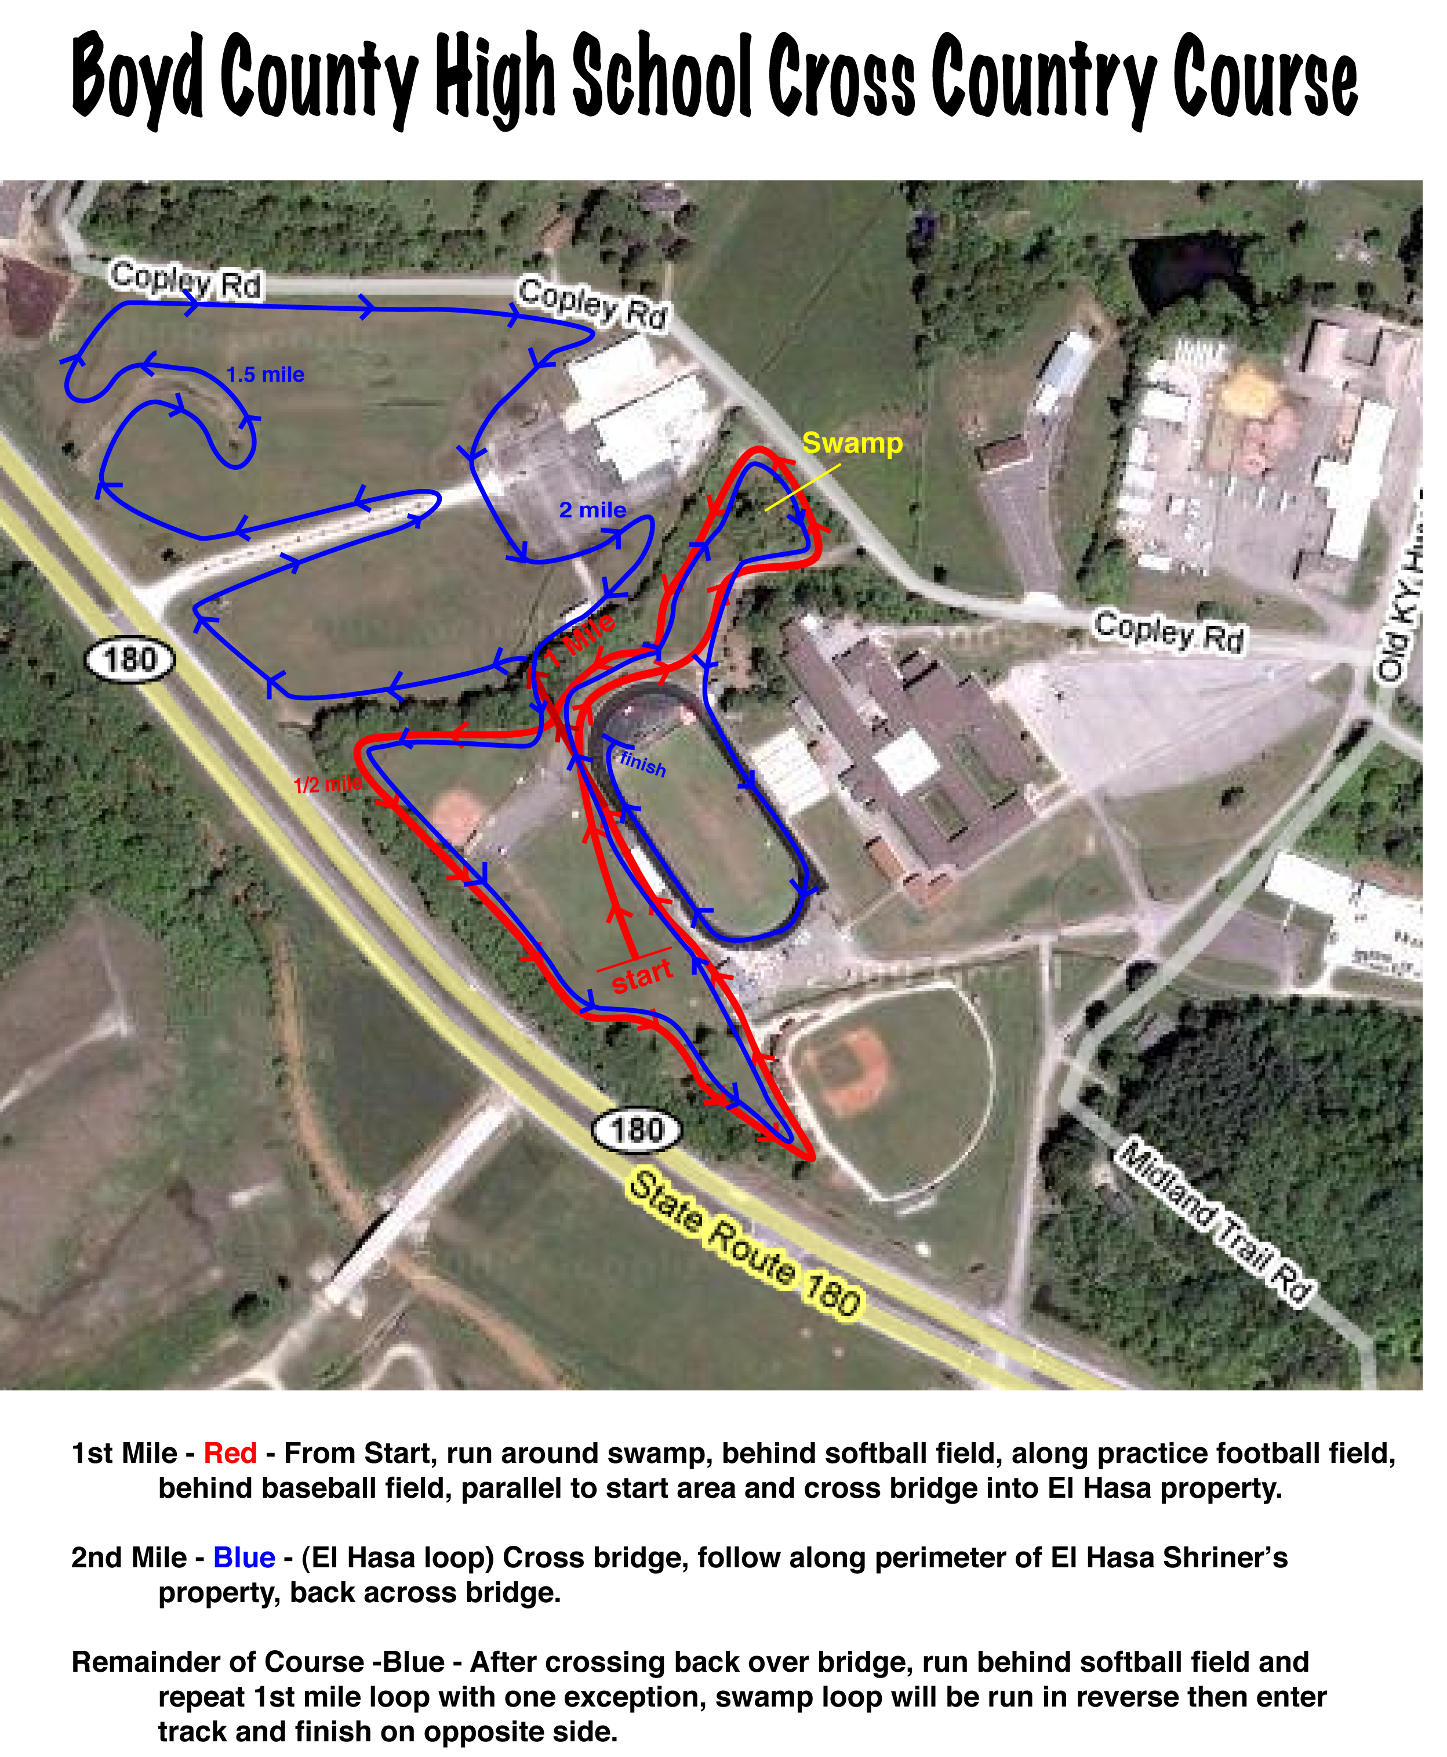

Middle School Course – Athletes run directly into El Hasa Loop, return and complete BCHS loop and finish on track. (Start directly to blue line, finish with red line)

Elementary Course - Athletes run the BCHS Loop only, and finish on the track. (Red line into track to finish)

