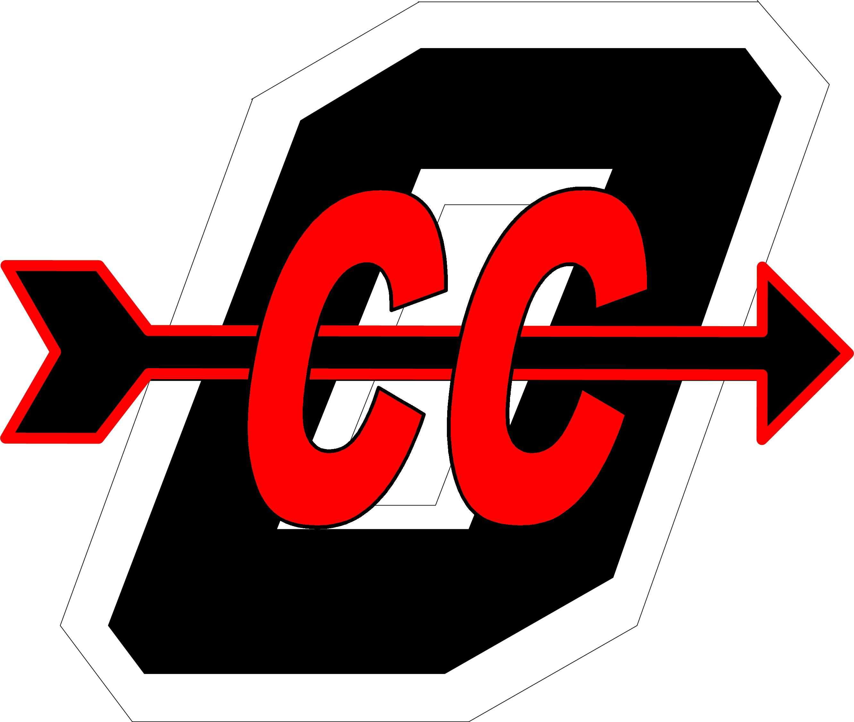

47th Annual Owensboro Cross Country Invitational

Coaches,

You and your cross country team are invited to participate in the 47th annual Owensboro Cross Country Invitational. Our competition will again be held at the beautiful and challenging Yellow Creek Park, site of the 2011 KY-IN Border Clash, 2010 Fast Cats Classic and 2010 Class 3A Region 1 Championships. The course layout provides many opportunities for coaches, families, and fans to observe the competition. Race distances will be 5K for high school, 3K for middle school, and 1K for elementary. Awards will again be generous and t-shirts will be available to purchase.

Registration should be received by Wednesday, September 7th HYTEK entry and scoring will be used.

Elementary races will be for grades 6 and under. Middle School races will be for grades 8 and under.

When: Saturday, September 10th, 2010

Where: Yellow Creek Park - 5710 Hwy. 144 Owensboro KY 42303

Races & Awards: Coaches Meeting 7:30

Race | Distance | Time | Awards
Elementary Girls | 1K | 8:00 | 3 teams30 runners
Elementary Boys | 1K | 8:30 | 3 teams, 30 runners
High School Girls | 5K | 9:00 | 5 teams, 30 runners
High School Boys | 5K | 9:45 | 5 teams, 30 runners
Middle Girls | 3K | 10:30 | 4 teams, 30 runners
Middle Boys | 3K | 11:10 | 4 teams, 30 runners

Awards for the elementary will start at 9:00.

Hotels:

Executive Inn 270-926-8000
Fairfield Inn 270-688-8887
Hampton Inn 270-926-2006
Super 8 270-685-3388

Owensboro Cross Country Invitational
Entry Form

School: _________________________________________________________

Coach: ____________________________________ Phone: _______________

Entry Fees:

A team consists of 5 or more runners in a race.

Varsity Teams $50 each for boys and girls or $10 per individual
Middle School Teams $30 each for boys and girls or $6 per individual
Elementary Teams $20 each for boys and girls or $5 per individual

Check each race you will be entering a team in or list the number of individuals:

Girls Elementary: ______ Boys Elementary: _____
Girls Middle: ______ Boys Middle: _____
Girls Varsity: ______ Boys Varsity: _____

Total: $_____________

If you have questions, contact:

Mark Rowe 270 302-3282

or

Summer Bell 270 315-1228

E-mail HYTEK entries to: Lil Brunson lillie.brunson@daviess.kyschools.us

Mail entry form and fees to:

Owensboro High School
Attn: Mark Rowe/Summer Bell
1800 Frederica Street
Owensboro, KY 42301

