4th Annual
Graviss McDonald’s Restaurants
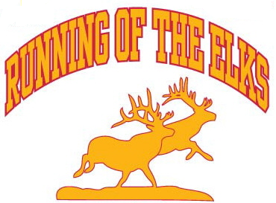
Cross Country Meet

September 17th, 2011

Location: State Archives on Coffee Tree Road in Frankfort, KY

Dear Coaches:

Elkhorn Middle School (Coach Jim Beason) and Franklin County High School (Coach Kelly Lewis) in Frankfort Kentucky will be hosting the “Graviss McDonald’s Restaurants Running of the Elks” Cross Country Meet on September 17, 2011. This meet will offer Elementary, Middle School, and High School races at the State Archive in Frankfort Kentucky where the Vietnam Memorial is located. We are hoping to see as many local schools and others at this event as possible.

Schedule & Entry Fees:

Race | Time | Distance | Team Fee | Individual Fee | # of runners | Individual Awards
Coaches Meeting | 9:45 AM
Girls High School | 10:00 AM | 5000 meters | $40.00 | $8.00 ($40 max) | No limit | 25
Boys High School | 10:45 AM | 5000 meters | $40.00 | $8.00 ($40 max) | No limit | 25
High School Awards | 11:30 AM
Girls Middle School (6, 7, & 8th grade) | 11:45 AM | 3000 meters | $35.00 | $7.00 ($35 max) | No limit | 25
Boys Middle School (6, 7, & 8th grade) | 12:15 PM | 3000 meters | $35.00 | $7.00 ($35 max) | No limit | 25
Middle School Awards | 12:45 PM
Girls Elementary (5th grade & under) | 1:00 PM | 1500 meters | $30.00 | $6.00 ($30 max) | No limit | 25
Boys Elementary (5th grade & under) | 1:30 PM | 1500 meters | $30.00 | $6.00 ($30 max) | No limit | 25
Elementary School Awards | 2:00 PM

THERE IS NO LIMIT (ONE FEE ANY SIZE TEAM) IN HIGH SCHOOL, MIDDLE, AND ELEMENTARY RACES, BUT SCORING WILL BE BASED ON TOP 7 RUNNERS PER TEAM. NOTE: A RUNNER IS NOT PERMITTED TO COMPETE IN MULTIPLE DIVISION LEVELS. IF THIS DOES OCCUR, BOTH TEAMS RUNNER RAN FOR WILL BE DISQUALIFIED.

Awards:
Top two (2) teams in each race receive trophies at associated presentation.
Top six (6) runners will be presented plaques at their associated presentation.
The remaining places through twenty-fifth (25) place will receive a ribbon.
(RIBBONS: Will be sent to teams within a weeks time with runners name place and time on backs)
NOTE: Awards are subject to change depending on the number of runners/teams.

Meet Entry Deadline:
Team Entries will be accepted until Monday September 12th, 2011 at midnight (EST). Unattached runners entries will be accepted until Saturday September 17, 2011 at 9:30 AM (EST).

Early Submission Discount:
Team entry fee submissions postmarked by August 26, 2011 will be discounted $5.00 per Entry Level.
(ie Elementary Boys $30.00 and Elementary Girls $30.00 = $60.00 – discount for entry level = $55.00) Only one discount per entry level will be accepted.

Mail entry fees to:
“Graviss McDonald’s Restaurants Running of the Elks”, Attention: Jim Beason, 204 Farmbrook Circle, Frankfort, KY 40601. Please make checks payable to “Elkhorn Middle School Cross Country” and note in the memo area “CC Meet Fee”. Entry fees should be post marked no later than September 7th, 2011.

Send Team Entries to:
Email Frank Miklavcic (fmiklavcic@aol.com) your Hytek Team Manager entries. Only Hytek Team Manager entry files will be accepted. Information on using the free version of Hytek Team Manager is at www.ktccca.org.

For individual questions contact:
Coach Jim Beason at coach.beason@fewpb.net via email. Elkhorn Middle School phone number is 502-695-6740. EMAIL IS PREFERRED, DUE TO NOT BEING PRESENT AT THE SCHOOL.

Please note that we are looking to have a concession stand and meet T-shirt available during the meet.

Directions to the State Archives:

From Lexington to Frankfort:
Take I-64 West to the first Frankfort exit. Take US 60 West to the East-West Connector (676). Follow the Connector to Coffee Tree Road (just before you get to the river) Take a left onto Coffee Tree Road. Follow Coffee Tree up and around the hill until you see the Vietnam Memorial.

From Louisville to Frankfort:
Take I-64 East to the first Frankfort exit. Take 127 North to the East-West Connector (676). Follow the Connector until you cross the Kentucky River. Across the bridge take the first right. This is Coffee Tree Road. Follow Coffee Tree up and around the hill until you see the Memorial.

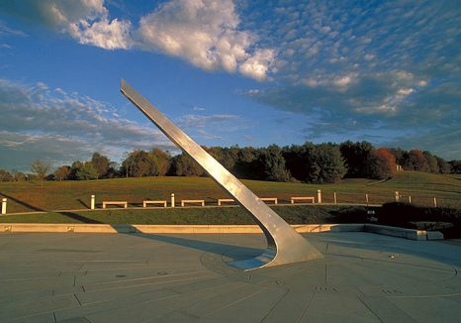

Picture: Vietnam Memorial where the “Running of the Elks” will take place.

