

Martha Layne Collins High School and Middle School Cross Country teams invite your teams to race in the First Annual Collins Titans Cross Country Classic in Shelbyville, Kentucky. The meet will be held at the site of Shelby County Invitational on Saturday, October 8, 2011.

Race features: The race will be held at Shelby County’s course which is the site for the region 3 class AA race. The course is well maintained and very spectator friendly.

Entry Deadline: All entries are due on or before Friday, September 30th, 2011, via Hy-Tek’s Team Manager or Team Manager Lite. Entries should be sent to: Linda Sarrett at
Linda.Sarrett@henry.kyschools.us and/or sarrettl@aol.com. Please also copy Stephen Drawbaugh at stephen.drawbaugh@shelby.kyschools.us.
Paper entries will be charged an additional $25 fee. Entries submitted after Friday, September 30th, will be charged an additional $30 late fee. The Hy-Tek meet file will be available later in
the summer via KTCCCA website.

Schedule & Entry Fees:

Event | Distance | Start Time | Team Fee | Individual Fee | Awards
Open | 5000m | 8:15 |  | $15 | Top 2
Girls Varsity | 5000m | 9:00 | $45 | $10 | Top 2 trophies  3-15 medals
Boys Varsity | 5000m | 9:45 | $45 | $10 | Top 2 trophies  3-15 medals
Girls JV | 5000m | 10:30 | $35 | $8 | Top 2 trophies  3-15 medals
Boys JV | 5000m | 11:15 | $35 | $8 | Top 2 trophies  3-15 medals
Girls Middle School | 3000m | 12:30 | $35 | $8 | Top 2 trophies  3-15 medals
Boys Middle School | 3000m | 1:00 | $35 | $8 | Top 2 trophies  3-15 medals
Girls Elementary | 1 mile | 1:30 | $35 | $8 | Top 2 trophies  3-15 medals
Boys Elementary | 1 mile | 2:00 | $35 | $8 | Top 2 trophies  3-15 medals

Directions: See attached map
From I-64 Exit 35:
- North onto KY 53.
- Right at light onto US 60E (McDonald’s Restaurant).
- Left at light onto Rocket Lane (Shelby County High School on left).
- East Middle School is located at the end of Rocket Lane on the left.

Parking:
All parking will be at East Middle School and Wright Elementary on Rocket Lane. Buses will need to drop runners off at East Middle School and park at Shelby County High School. No vehicles permitted near the greenhouses or the course. There will be a $1 per person charge at the entrance to the course.

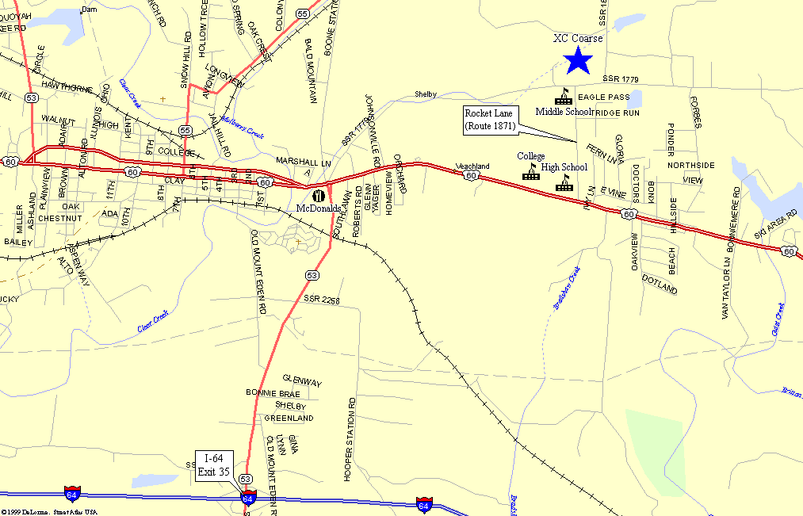

2011 Team Entry Form

School Name: _________________________________________________
Boys Coach Name:________________________________ Contact Phone: _____________
Email address: ________________________________________________________
Girls Coach Name: _________________________________ Contact Phone: _____________
Email address: ________________________________________________________

Event | Total Runners Entered | Number of Teams (5 to 10 runners per team) | Team Fee | Number of Individuals | Individual Fee | Total Fee
Open |  |  | ------- |  | $15
Girls Varsity |  |  | $45 |  | $10
Boys Varsity |  |  | $45 |  | $10
Girls JV |  |  | $35 |  | $8
Boys JV |  |  | $35 |  | $8
Girls Middle School |  |  | $35 |  | $8
Boys Middle School |  |  | $35 |  | $8
Girls Elementary |  |  | $35 |  | $8
Boys Elementary |  |  | $35 |  | $8

Totals: ________
Entry Fees:
Make checks payable to Martha Layne Collins High School and send along with entry form to:

Stephen Drawbaugh, Head Cross Country Coach
Martha Layne Collins High School
801 Discovery Blvd.
Shelbyville, KY 40065

