37th Boyd County Cross Country Invitational
October 13th 2012
@ Boyd Co HS

You are invited to the 37th Boyd County High School Cross Country Invitational. This year the meet will be located on the Boyd County High School Campus and adjacent El Hasa Shriner’s property. Entries should be received no later than October 8th. Send rosters via Hytek’s TM-Lite or team manager with names (first & last), gender and grades to shawn.thornbury@boyd.kyschools.us

Schedule of Races:
Girls Elementary 9:00 AM 1600 meters
Boys Elementary 9:30 AM 1600 meters
Girls Middle School 10:00 AM 3000 meters
Boys Middle School 10:45 AM 3000 meters
Girls Varsity Race 11:30 AM 5000 meters
Boys Varsity Race 12:30 PM 5000 meters

Awards:
Elementary- 1st place team trophy
Medals for the first 10 finishers. Ribbons for all other finishers
Middle School- 1st and 2nd place team trophies
T-shirts for the first 10 individuals
Varsity- 1st, 2nd, and 3rd place team trophies
T-shirts to the first 20 finishers in each varsity race.

Fees:
School Participants: $50.00 per team (minimum 5 Boys or Girls)
$85.00 for both Boys and Girls teams,
$10.00 per individual
If you plan on bringing two of the following: Elementary, Middle and Varsity (Boys and Girls) = $150.00…all three = $175.00

General Information: For coaches and runners (inform parents as well)

- Parking for this event will be in the lot IN FRONT of the high school. The parking lot at the bottom between the baseball field and track will need to be kept clear for athlete drop off and pick up.
- Team areas will be in the practice football field closest to the softball field. Athletes and coaches should be aware not to impede the start or any part of the course when setting up tents, etc…
- Each Varsity team may enter as many runners as they wish.
- First five finishers will determine the team score. Anyone with less than five runners will be displaced.
- Only coaches and athletes (during competition) will be allowed onto the El Hasa Shriners property.
- They have also asked that NO ONE use their parking lot.
- The course will finish on the track. Spectators may watch the finish anywhere along the outside of the fence surrounding the track.

For any questions concerning hotel accommodations, directions or any other meet information contact:

Dirk Hollar
BCHS Track and Cross Country Coach
Work- 606-928-7100
Fax- 606-928-1312
Email- dirk.hollar@boyd.kyschools.us or shawn.thornbury@boyd.kyschools.us

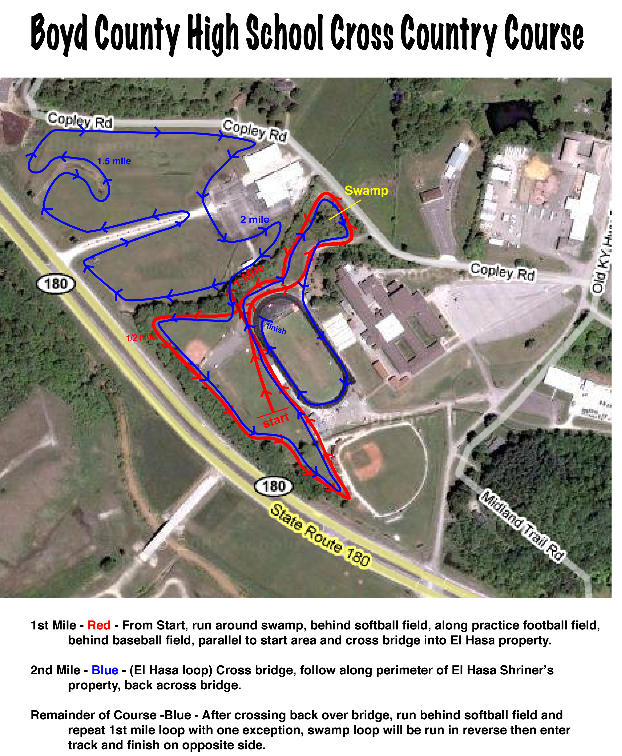

Middle School Course (3000m) – Athletes run directly into El Hasa Loop, return and complete BCHS loop and finish on track. (Start directly to blue line, finish with red line)

Elementary Course (1600m)- Athletes run the BCHS Loop only, and finish on the track. (Red line into track to finish)

