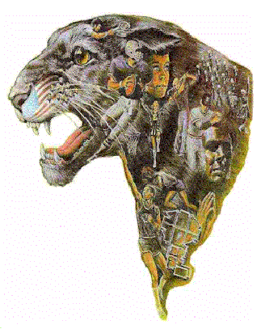

North Hardin Elizabethtown John Hardin

Central Kentucky Run for the Gold
October 20, 2012
Elizabethtown, Kentucky
“Under the Lights”
The Cross Country teams from Elizabethtown, John Hardin, and North Hardin would like to invite your team to the 1st annual Central Kentucky “Run for the Gold” Cross Country
Invitational on Saturday, October 20, 2012.

Our course will be located at the brand new Elizabethtown Sports Park in Elizabethtown, Ky. We will be hosting events ranging from Elementary through Varsity, with the JV and Varsity races in the evening under the lights. Please consider joining us at the first cross country meet at the park.

Race Schedule:
Race Time Distance Team Fee Individual Fee
Elementary Boys | 3:45 | 2500 | $30
Elementary Girls | 4:15 | 2500 | $30
Middle School Boys | 4:45 | 3000 | $40
Middle School Girls | 5:15 | 3000 | $40
Girls JV | 5:45 | 5000 | $50
Boys JV | 6:30 | 5000 | $50
Girls Varsity | 7:15 | 5000 | $60
Boys Varsity | 8:00 | 5000 | $60

There will be a limit of 10 runners in each race. Multiple team entries are permitted.

Awards
Team trophies will be awarded to the top 2 teams in each race as well as individual medals to the top 10 finishers.

For more information please contact:
Coach John Russell
John.russell@hardin.kyschools.us
270-272-3519

Mail entry fees to: John Hardin High School Cross Country Boosters

JHHS Cross Country c/o
Meg Haebig
John Hardin High School
384 W. A. Jenkins Road
Elizabethtown, KY 42701

Please send Hy-Tek entries to: jamie.hardin@larue.kyschools.us

Directions to the Elizabethtown Sports Park

Elizabethtown is located at the intersection of I-65, the Bluegrass Parkway, and the Western Kentucky Parkway, at exit 94 on I-65.
The Entrance to the park is located at 1401 West Park Road. Please note that this is a newer section of West Park Road and MAY NOT show up on all GPS and navigation systems. Here are the driving directions:
From I-65 headed South, take exit 94, stay right onto Mulberry/US 62.
From I-65 headed North, take exit 94, turn left at the top of the ramp onto Mulberry/US 62.
From the Bluegrass Parkway, at the end of the parkway, take I-65 North, stay right onto the Exit 94 ramp, turn left at the top of the ramp onto Mulberry/US 62.
Once on Mulberry/US 62:
Follow Mulberry/US 62 through downtown, travel approx. 5 miles (you'll pass Police Station and Central Hardin High School)
Just past a McDonald's on the right, turn RIGHT onto Ring Road (Hwy 3005)
Just past Flink Ink on the right, turn RIGHT onto West Park Road at the Elizabethtown Sports Park Column
Follow West Park to the main entrance, which will be on the LEFT
(If you get to Nolin/RECC or the stoplight at St.John Road/Hwy 1357, you passed West Park Road.)
To help pay for the use of the Elizabethtown Sports Park, there will be a $5.00 charge per car.
Central Kentucky Run for the Gold
October 20, 2012
Elizabethtown, Kentucky

Team Entry Form

School:________________________________
Address:_______________________________
_______________________________
_______________________________
Boys Coach Name:_______________________
Contact Phone:____________________
Email:____________________________

Girls Coach Name:_______________________
Contact Phone:____________________
Email:____________________________

Race # of teams Team Fee # of individual Fee Total Fee
Elementary Boys |  | $30 |  | $7
Elementary Girls |  | $30 |  | $7
Middle School Boys |  | $40 |  | $8
Middle School Girls |  | $40 |  | $8
Girls JV |  | $50 |  | $9
Boys JV |  | $50 |  | $9
Girls Varsity |  | $60 |  | $10
Boys Varsity |  | $60 |  | $10

Total_________
Please mail this form and check payable to:

John Hardin High School Cross Country Boosters

JHHS Cross Country c/o
Meg Haebig
John Hardin High School
384 W. A. Jenkins Road
Elizabethtown, KY 42701

