Go to:
http://www.hy-tekltd.com/downloads.html
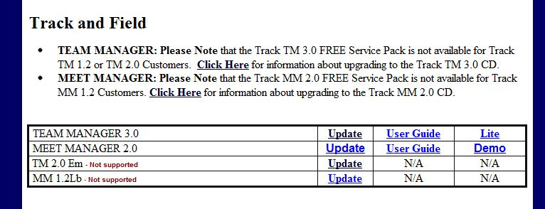
Click on “Lite” (See graphic above)
Lite – Under Track and Field (in the row labeled Team Manager 3.0)
Download to your computer and then install the Application.

Start the Program TFTM Lite 
Click on “FILE” at top of screen and select “Open/New”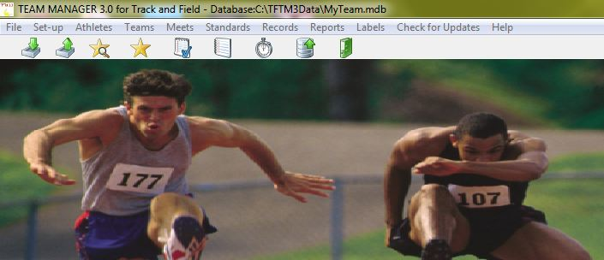
Main Menu

By Default TFTM Lite uses the File Name “My Team” . If you wish to change the name of your file, just type over this and name the file anything you like and click “Open”.
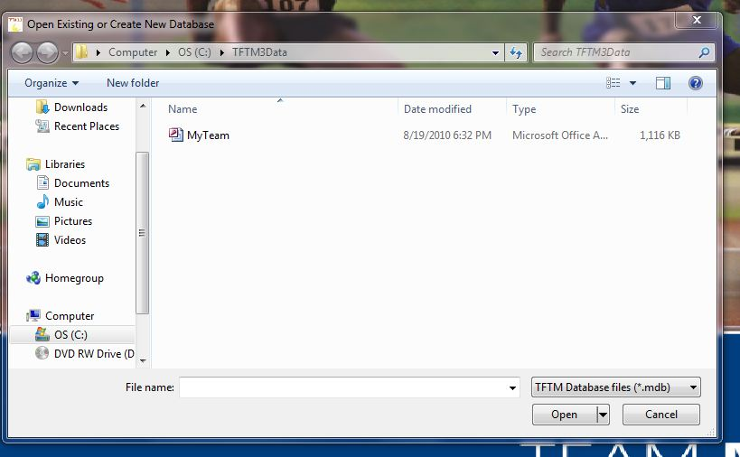

The “System Preferences” box will then pop up.

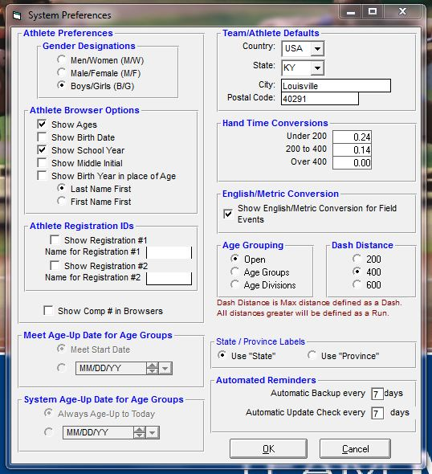

Change or Set:
- Gender Designations
  - Check Boy/Girl

Team Athlete Defaults

To your specific area

Athlete Browser Options
  - Check – Show Ages and School Year
- Age Grouping – Check “Open”

All other settings for this box should be OK by default.
Click OK to Close this Box

Click on “Set-up” in the Top of the Screen
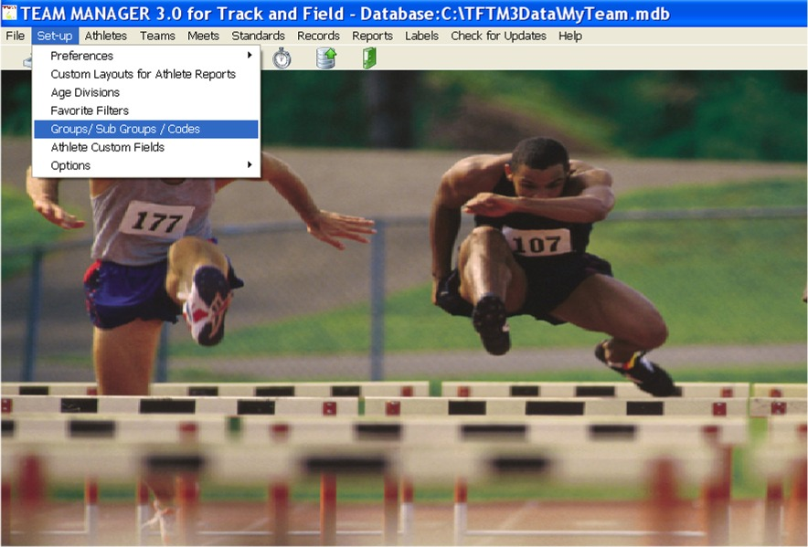
Highlight and select “Groups/Sub-Groups/Codes”
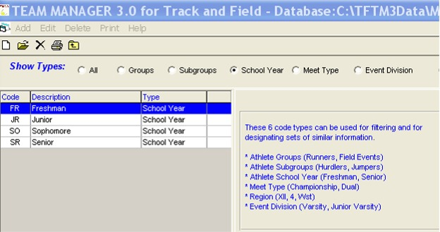
In the Section “Show Types” Check the button “School Year”
Hy-Tek by default uses FR, SO, JR, and SR as codes for grades. In KY athlete codes are designated by School Year (i.e. SR = 12). You will need to change the Codes as follows.
Begin by double clicking directly on the Code “FR”
A Box will open for “Code Maintenance”
Change the Code for Freshman to 09 (it is important to place the 0 (Zero) .
Click OK
Repeat this procedure to change So, JR and SR as well.

You now need to add the Codes for Grades K-8
Click on the word “Add” near the top of the Screen
“Code Maintenance” again pops up.
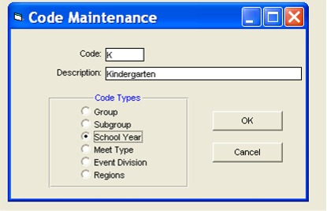

Type “K” in the Code field
Type “Kindergarten” in the Description
Select the Button “School Year”.
Click on “OK”

Repeat this Procedure for all remaining grades 1-8 using:
01 | First Grade
02 | Second Grade
03 | Third Grade
04 | Fourth Grade
05 | Fifth Grade
06 | Sixth Grade
07 | Seventh Grade
08 | Eighth Grade

Click on the smaller of the two “X”s near the top right of the screen to close this area and return to Main Menu

Add Your Team
Click on the word “Teams” near the top of the screen in the Main Menu.
After the screen changes , Click on the word “Add” near the top of the screen.
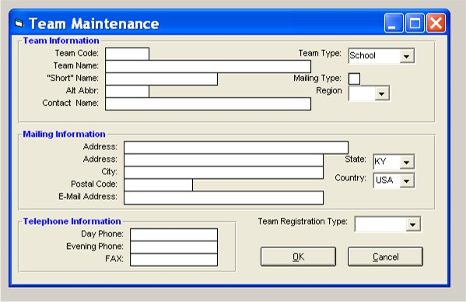

Set the “Team Type” to “School”
Fill in the “Team Code” field with the appropriate Code. A list of known codes can be found at:
http://ktccca.org/hytek_information/trackandxcabbreviations.pdf
Fill in the “Team Name” and “Short Name” fields with your schools information

All of the remaining fields are optional but do not necessarily need to be filled in.

Click “OK” to close this box.
Click on the smaller of the two “X”s near the top right of the screen to close this area and return to Main Menu

Add your Athletes

Click on the word “Athletes” at the top of the Main Menu.
Now Click on the word “Add” near the top of the screen.
The “Athlete Information” box pops up.
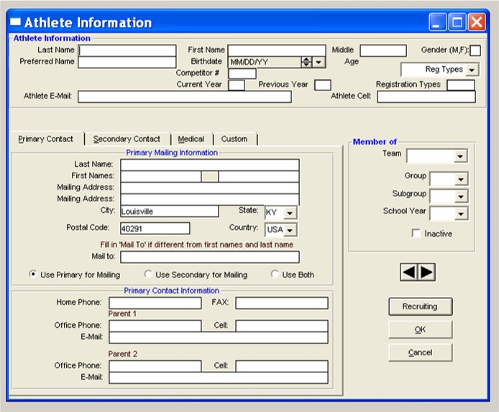
Fill out the necessary information for the Athlete.
Necessary info:
- Last Name
- First Name
- Gender
- All other “fill in the blank information is” not needed and can be ignored.

Under the heading of “Member of”
Select your team from the dropdown list next to “Team”
Select the athletes grade from the dropdown list next to “School Year”

Make no other changes to the fields on this box.

Click “OK”

Pay Close Attention to this part!
Hy-Tek is a little quirky in that after clicking “OK” you are returned to a blank “Athlete Information” box, without showing the information that you had previously entered in the background. It appears as though it has lost the information that you just entered. This is FINE.
Your information is not gone.
Continue adding athletes and Clicking “OK” each time when completing the athletes information
After entering your last athlete, click on the “Cancel” button.
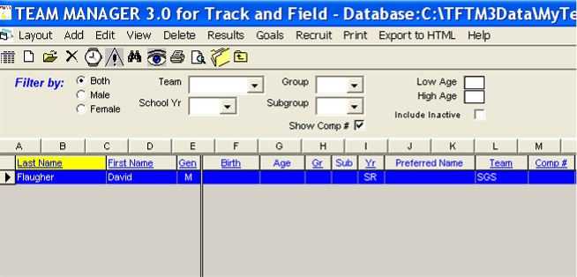

The Add Athlete box will close and you will see the “Athlete Browser” screen where all of your athletes should now appear.
If you made a mistake or need to edit an athletes information, just double click on the athletes name and his or her “Athlete Information” box will open.

Click on the smaller of the two “X”s near the top right of the screen to close this area and return to Main Menu

Getting the Information to the Meet Director or Hy-Tek Operator

There will be two primary methods used to enter athletes in Meets and Events.

Method 1 uses Event Files that are provided by the Meet Director or Hy-Tek Operator.

Method 2 creates a file (Roster) containing all of your eligible athletes that is then sent to the Meet Director or Hy-Tek Operator.

Please make sure you are clear on the entry method before proceeding.

METHOD 1 Working with EVENT Files

Meet Directors may provide teams/coaches with an “Event File”. This file works within HY-Tek to establish the races/events in a meet inside the Hy-Tek program thereby allowing coaches to individually designate Athletes and Teams to particular race/events.

When an event files is will sometimes be sent by email as an attachment to coaches via the List-Serve. At other times Coaches will have to go to a web site such as www.ktccca.org to download the file(s).
We will assume for this purpose that you need to get the file from a web site.
After finding the page that contains the Event File, point and RIGHT Click on the file (in the case of the Event Files on KTCCCA.org they are shown as .zip in the schedule table).
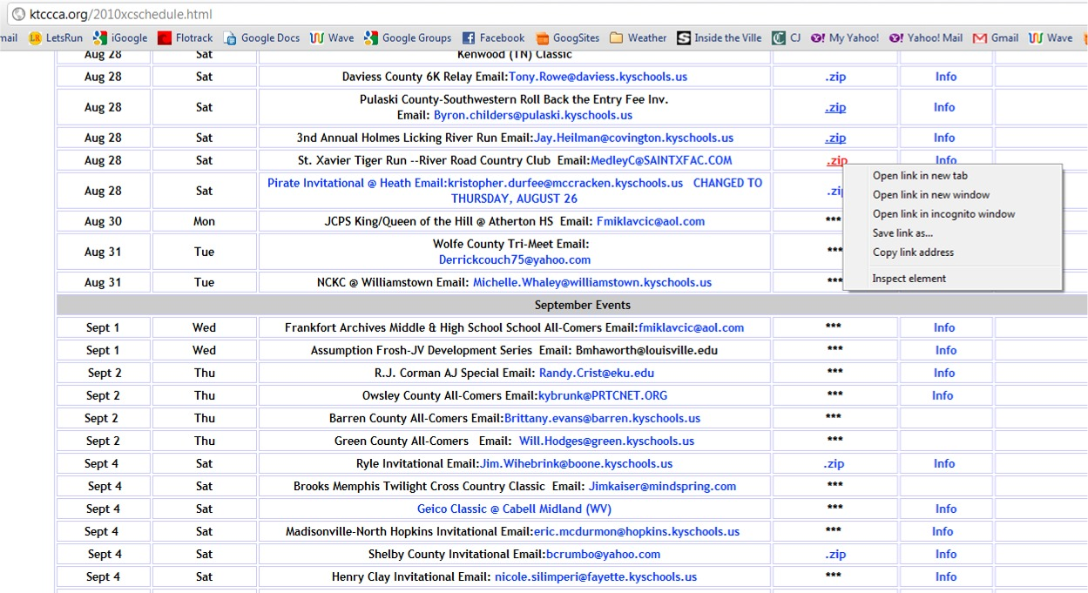

From the list that becomes visible after RIGHT Clicking, select “Save link as…” Save file to a place on your computer that you will be able to find easily such as your Desktop.

Import File Into Hy-Tek Team Manager

With Team Manager running, click on “File” from the Main Menu near the top of the screen.

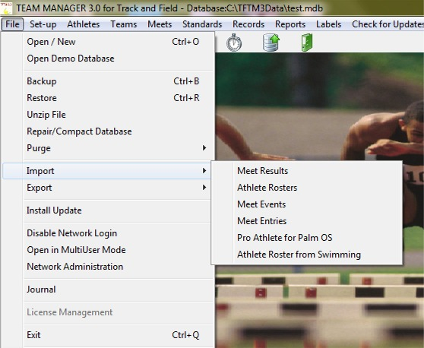

Select “Import” from the available choices.

Then Click on (Select) “Meet Events” .

The following will display
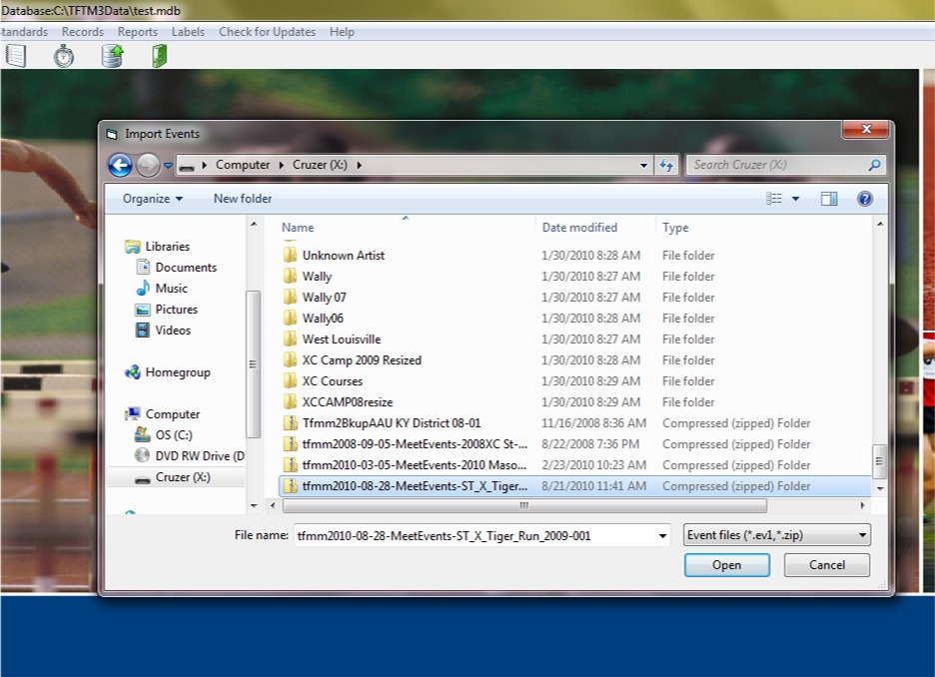

Navigate to the place/directory (such as your desktop) that you downloaded/saved the Event File. Select the file and click “Open”.

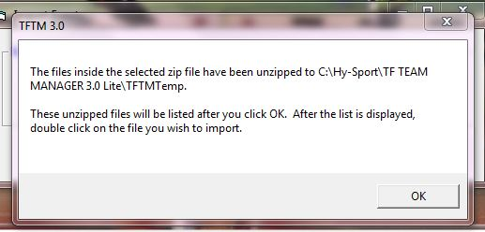

The above will display.
Click “OK”
Hy-Tek is now asking for you to continue Importing the File.
The Following will display.

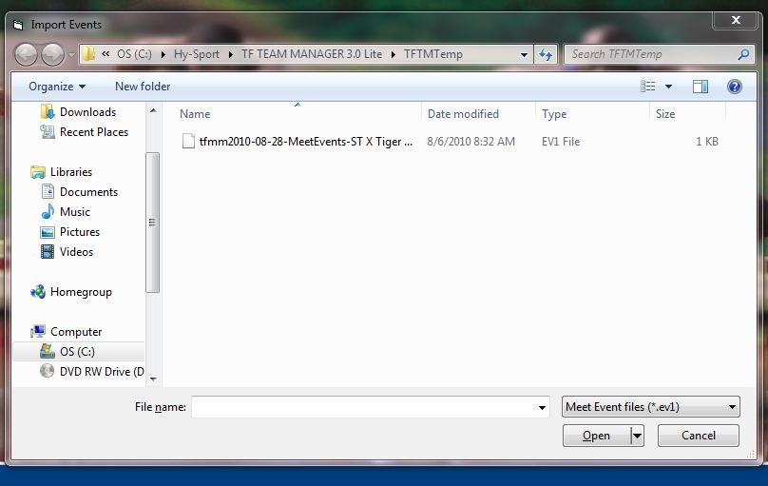

Select the file that is displayed under the heading “Name” (often begins with tfmm…) and then Click “Open”

Hy-tek then asks you to confirm that this is the Meet that you were trying to Import.
If everything appears correct, Click “OK”

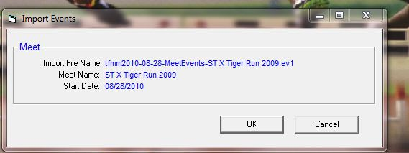

Hy-Tek will then Import the Events and display a message listing the amount of events that have been imported: Click “OK” and you will return to the Main Menu.

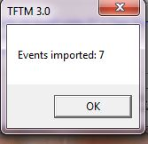

Its not time to assign your Athletes to Specific Events.

Begin by clicking on “Meets” at the top of the Main Menu
A browser style screen will appear listing all of the Meets that you have previously Imported.
There is more than one method for assigning Athletes to Events. For our purposes we will only use the “Entry by Event” method.
From the “Meets” Screen, select Entries from the Top Menu.

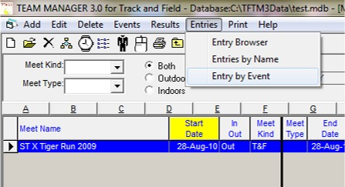

Now Select “Entry by Event” from the drop down Menu.

A new Screen will appear.

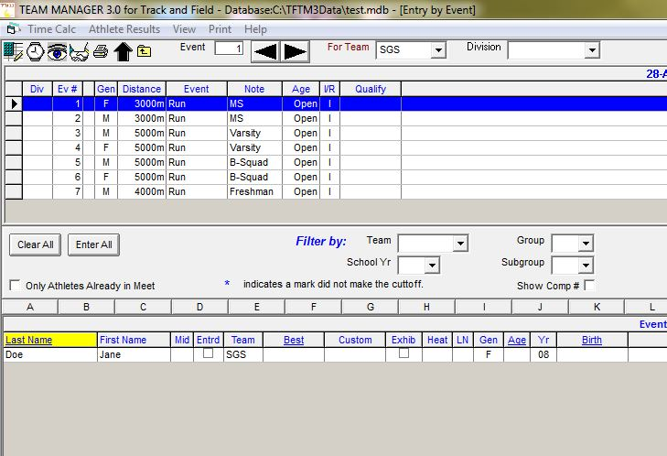

This screen will contain the Events that are set to be held in the meet near the top of the screen.

When you Select one of these Events (by single clicking on it), the table near the bottom will contain the Athletes that are of the Gender eligible to compete in that event. (so, when you have a female event selected only females will show in the list below)

To enter any of the athletes in that event, just click in the box for “Entrd” in the same row as the athlete that you wish to assign the event that is highlighted above.

After Checking the “Entrd” box the Athletes Row (or line) will then turn yellow, showing you that they are now listed as entered in that event.

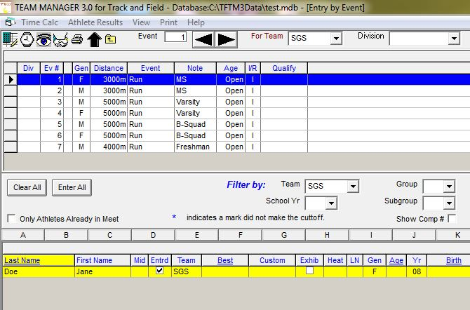

Repeat this procedure for all athletes that you wish to enter, paying close attention to the event that is highlighted above. Generally, Hy-Tek will allow you to enter any athlete of the correct Gender in any event. The program will not catch an error such as a 12th Grader being entered in a Freshman Event.

After completing your entries, click on the smaller “X” near the top right of the Screen to return to return to the “Meets” screen.

It is wise at this time to double check your entries using the Entry Browser.

Click on “Entries” in the Top Menu and select “Entry Browser”.

[Review your entries and make changes as needed by returning to the “Meets” screen (click on the small X near the top right of the screen) and select “Entries” then Select Entries by Event and edit as needed.]

Should your entries now appear correct, its time to “Export” an Entry file that will contain your work. (at this time you should still be in the “Entry Browser”)

Click on “Export Entries” in the Top Menu.
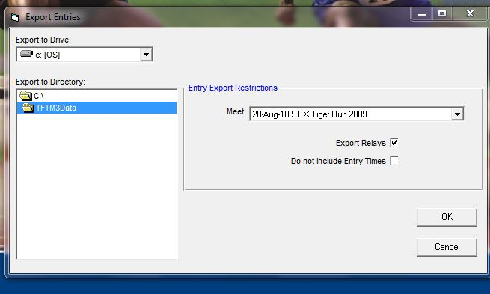
A box will appear asking you where you would like to store the file that you are creating. Again, navigate to a place/directory that you will be able to find and click “OK”.
Hy-Tek will Export the file to the place that you have designated and notify you with a box (similar to below) that tells you the name of the file. In the case shown below, the file name is “SGS-Entries001.zip”.
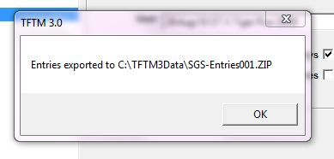

Click “OK” and return to your previous Screen.
Using your Email program, find and attach this file and send to the person designated. Sometimes this is the Meet Director, but is often the Hy-Tek Operator.

Method 2 Export Roster File
Occasionally a Meet Director or Hy-Tek Operator will request a “Roster” file instead of an event file. In this case follow the instructions below.

Click on the word “File” in the Main Menu.
Select “Export” from the list that appears.
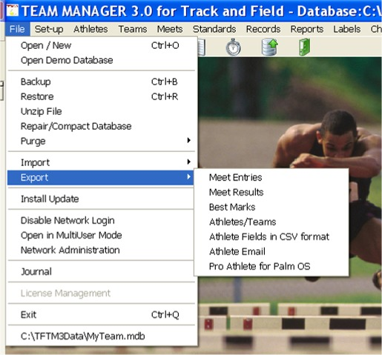

Select “Athlete / Teams”
The “Export Athletes” box pops up.
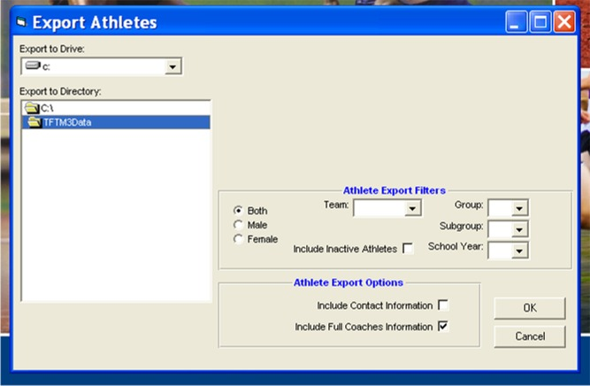

Select your team from the drop down list next to the word “Team”
(no need to change anything else)
Pay close attention to the “Export Directory” area, so that you will know the location of the file that you are creating.
Click “OK”
Your Roster file will be created and exported to the directory that was listed.
A box will pop up showing you the name of the file and its location on your PC.
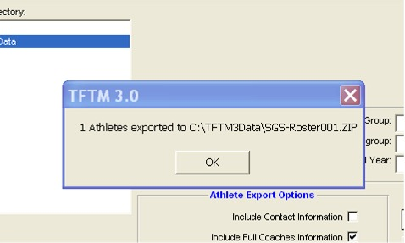

Click “OK” on this box.
Click the Red “X” in the “Export Athletes” box to close and return to Main Menu.

You are done with Hy-Tek (for now)
Using your Email program, find and attach this file and send to the person designated. Sometimes this is the Meet Director, but is often the Hy-Tek Operator.

